**Read from notes before this :- Basic defintions :- (Below content from Telusko and** [CodeSpace](https://www.youtube.com/channel/UCTI8_vW-CmKkZuWIU7Yi8BQ)**)**

**Ref : Telusko,** [**https://thecodingsimplified.com/design-pattern/**](https://thecodingsimplified.com/design-pattern/)

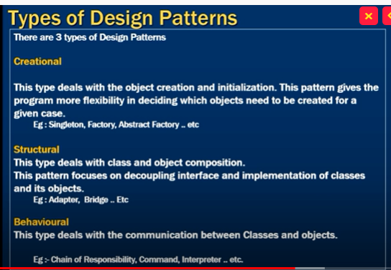

**Factory Design Pattern(Creational)**

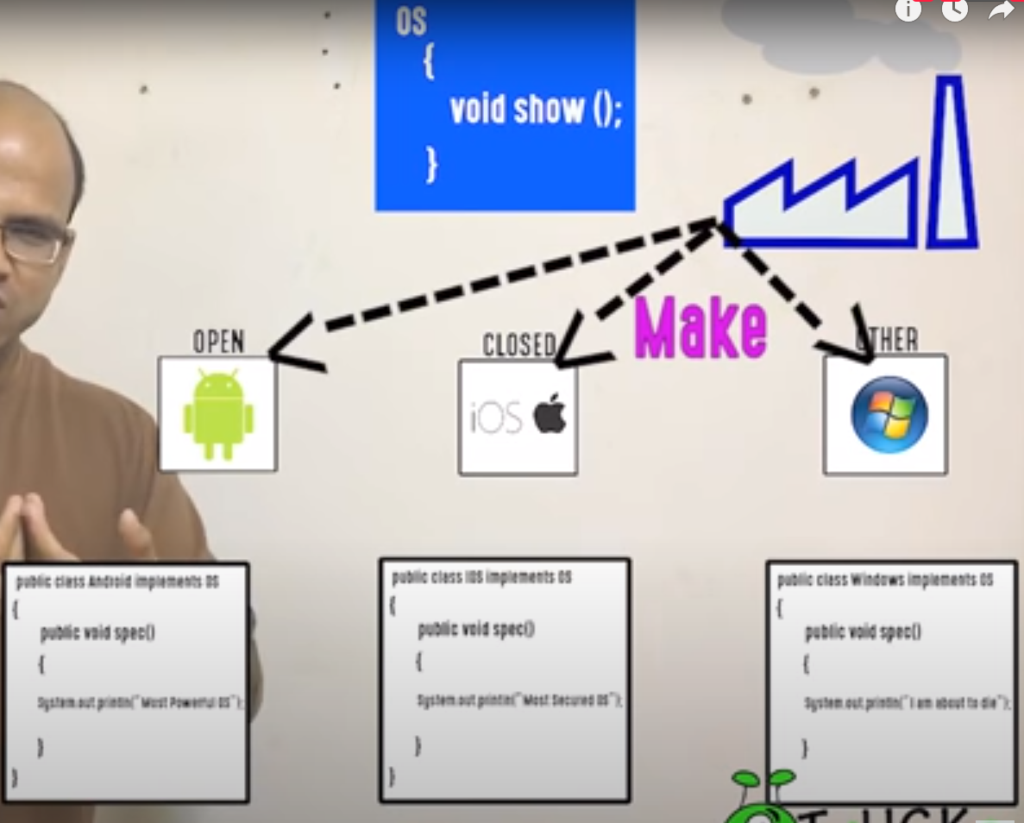

Without factory :-

OS Obj = new Android();

Obj.spec(); //Create Object Manually

With factory :-

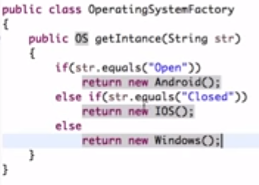

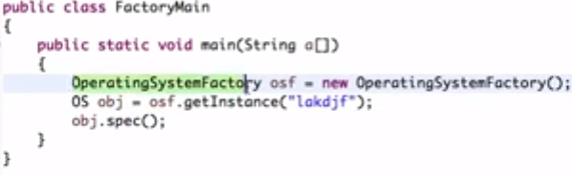

Builder Pattern(Creational)

When you want to set only few parameters of a object

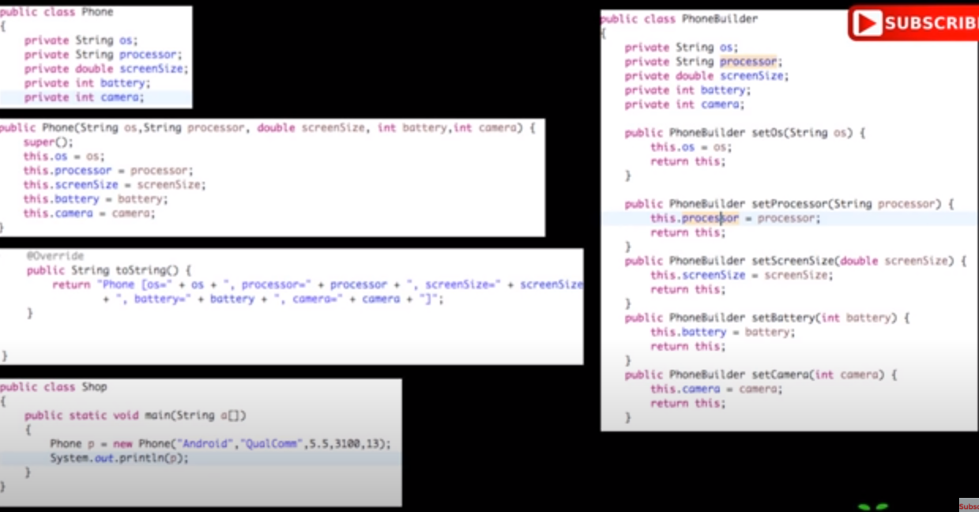



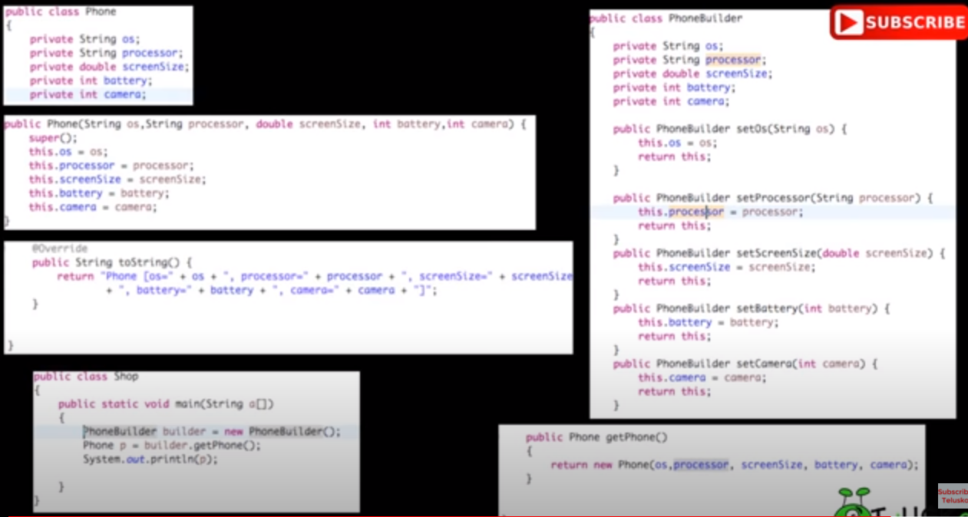

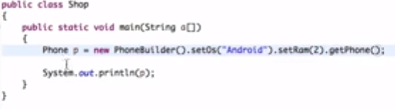

Example 2:-

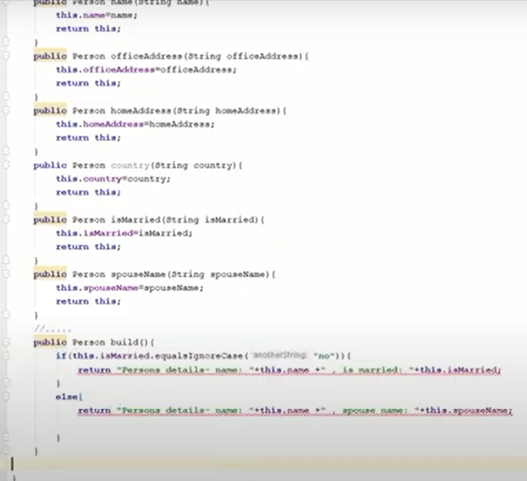 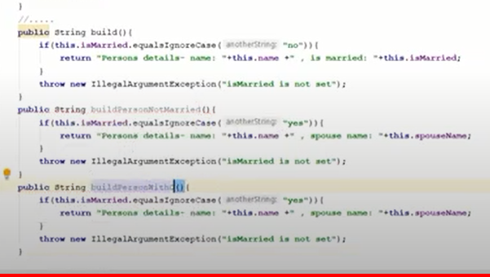

Can create object using :-

Person p = new Person().setName(“Ayush”.setContact(‘9881’).build(); -> build method return this

We can also use other build methods to check for some other functionalities while creating the object.

Adapter Design Pattern:- (Structural)

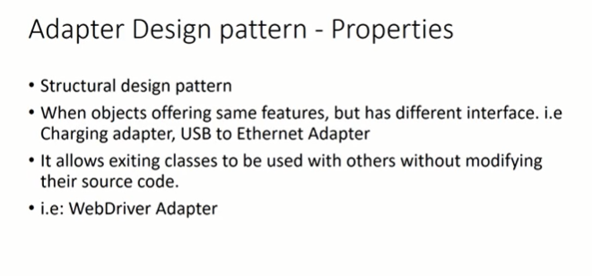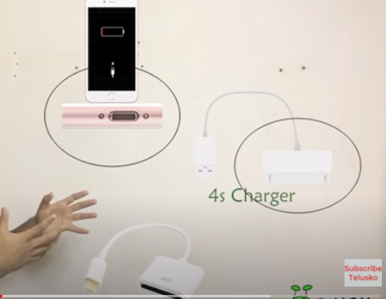

Adapter patterns are used when we have one object and not implementation of other, and we want to make use of other object as in case of iphone charger, we are making use of some other charger.

As in below example, we are trying to make use of pilot pen as we don’t have implementation of Pen Object, so we are using pilot pen.

We have got compiler class of Pilot Pen, and don’t have any implementation of Pilot object, we create a object in main from PenAdapter.

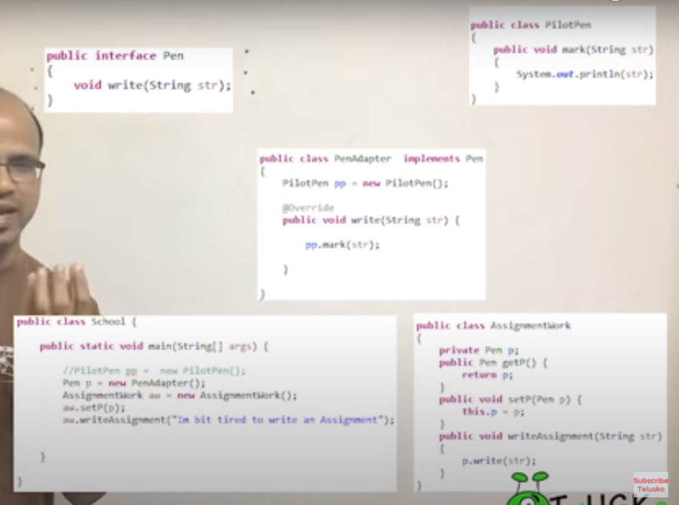

Example 2:- Coding Simplified

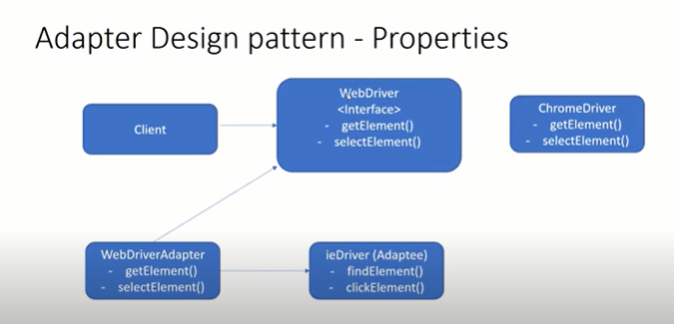 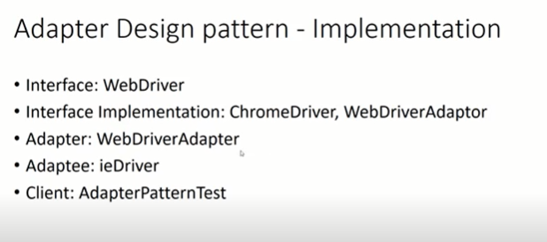

**package**adapter;  
  
**interface**WebDriver {  
  **public void**getElement();  
  **public void**selectElement();  
}  
  
  
**class**ChromeDriver **implements**WebDriver {  
  
  @Override  
  **public void**getElement() {  
    System.out.println("Get element from ChromeDriver");  
  }  
  
  @Override  
  **public void**selectElement() {  
    System.out.println("Select element from ChromeDriver");  
      
  }  
    
}  
  
**class**IEDriver {  
  
  **public void**findElement() {  
    System.out.println("Find element from IEDriver");  
  }  
  
  **public void**clickElement() {  
    System.out.println("Click element from IEDriver");  
  }  
    
}  
  
**class**WebDriverAdapter **implements**WebDriver {  
  
  IEDriver ieDriver;  
    
  **public**WebDriverAdapter(IEDriver ieDriver) {  
    **this**.ieDriver = ieDriver;  
  }  
    
  @Override  
  **public void**getElement() {  
    ieDriver.findElement();  
      
  }  
  
  @Override  
  **public void**selectElement() {  
    ieDriver.clickElement();  
  }  
    
}  
  
**public class**AdapterDesignPattern {  
  
  **public static void**main(String[] args) {  
    ChromeDriver a = **new**ChromeDriver();  
    a.getElement();  
    a.selectElement();  
      
    IEDriver e = **new**IEDriver();  
    e.findElement();  
    e.clickElement();  
      
    WebDriver wID = **new**WebDriverAdapter(e);  
    wID.getElement();  
    wID.selectElement();  
      
  }  
  
}

Composite Design pattern(Structural)

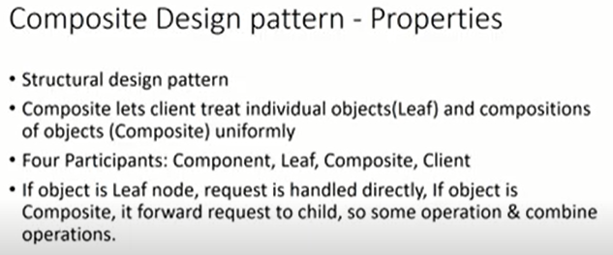 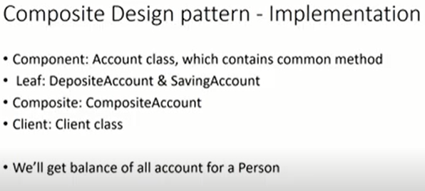

C : Computer will be composed of Cabinet and Peripheral. Cabinet will be composed of hardDriver, MotherBoard. Mother Board will consist of RAM and CPU. Peripheral will be consisting of Mouse, Key etc.

Composite dp is used when each object is composed of some other objects. The object which can be further divided are called as Leafs.

In Composite Design – you should be able to perform same function on parent as well what you are performing on child, as in example below : if you can calculate the cost of Keyboard, then you should be able to calculate the cost of Peripheral also and hence Cabinet in turn.

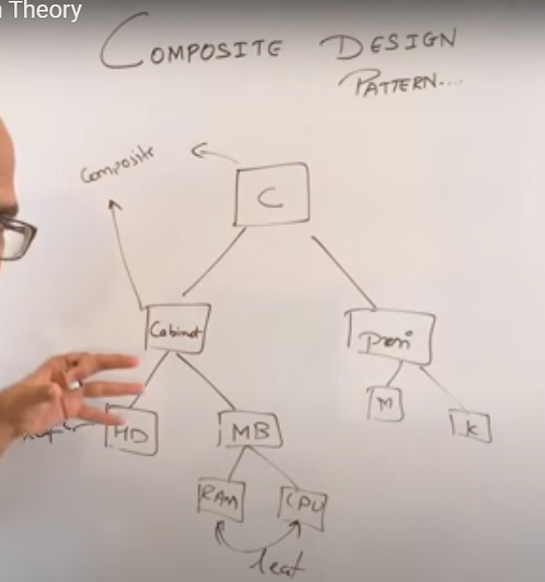

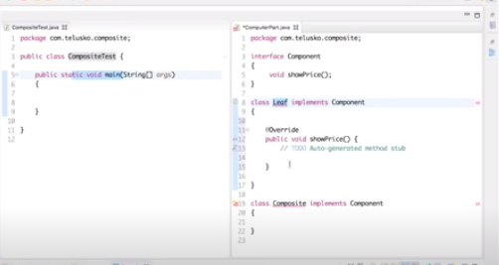 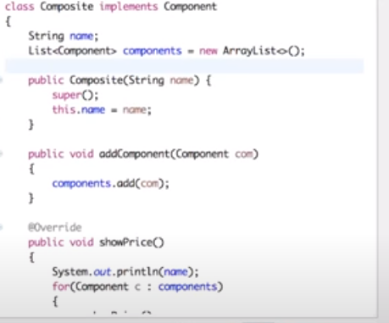

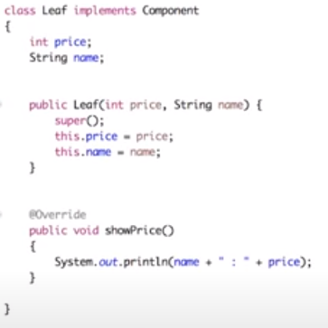 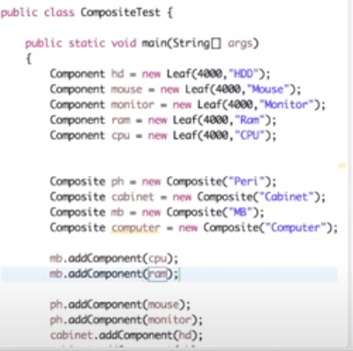

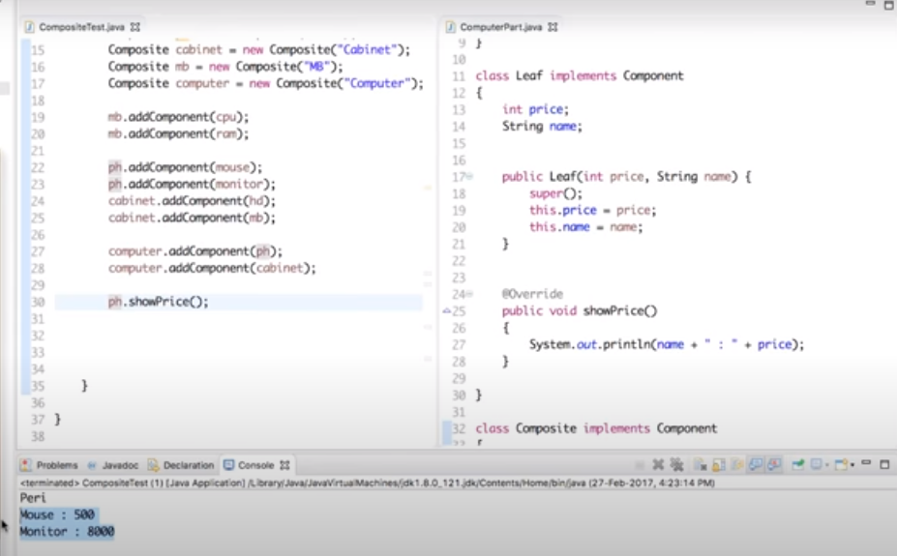

If we print computer.showPrice then it should print price for all the child objects.

**Example 2 :-**

**package**composite;  
  
**import**java.util.ArrayList;  
**import**java.util.List;  
  
**abstract class**Account {  
  **public abstract float**getBalance();  
}  
  
**class**DepositeAccount **extends**Account {  
  **private**String accountNo;  
  **private float**accountBalance;  
  
  **public**DepositeAccount(String accountNo, **float**accountBalance) {  
    **super**();  
    **this**.accountNo = accountNo;  
    **this**.accountBalance = accountBalance;  
  }  
  
  **public float**getBalance() {  
    **return**accountBalance;  
  }  
  
}  
  
**class**SavingAccount **extends**Account {  
  **private**String accountNo;  
  **private float**accountBalance;  
  
  **public**SavingAccount(String accountNo, **float**accountBalance) {  
    **super**();  
    **this**.accountNo = accountNo;  
    **this**.accountBalance = accountBalance;  
  }  
  
  **public float**getBalance() {  
    **return**accountBalance;  
  }  
}  
  
**class**CompositeAccount **extends**Account {  
  **private float**totalBalance;  
  **private**List<Account> accountList = **new**ArrayList<Account>();  
  
  **public float**getBalance() {  
    totalBalance = 0;  
    **for**(Account f : accountList) {  
      totalBalance = totalBalance + f.getBalance();  
    }  
    **return**totalBalance;  
  }  
  
  **public void**addAccount(Account acc) {  
    accountList.add(acc);  
  }  
  
  **public void**removeAccount(Account acc) {  
    accountList.add(acc);  
  }  
}  
  
**public class**Client {  
  
  **public static void**main(String[] args) {  
    CompositeAccount component = **new**CompositeAccount();  
  
    component.addAccount(**new**DepositeAccount("DA001", 100));  
    component.addAccount(**new**DepositeAccount("DA002", 150));  
    component.addAccount(**new**SavingAccount("SA001", 200));  
  
    **float**totalBalance = component.getBalance();  
    System.out.println("Total Balance : " + totalBalance);  
  }  
  
}

Prototype Design pattern(Creational)

This is used when an object creation is expensive and we want to make use of existing object and try to create a new object out of it.

We use clone method to create a new object from existing copy of the object.

Creating just clone(Calling clone) method will create a shallow copy of the object. We will have to override the clone method and provide own implementation to create a deep copy of the object.

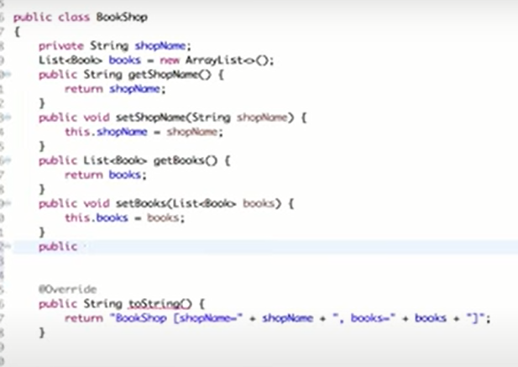 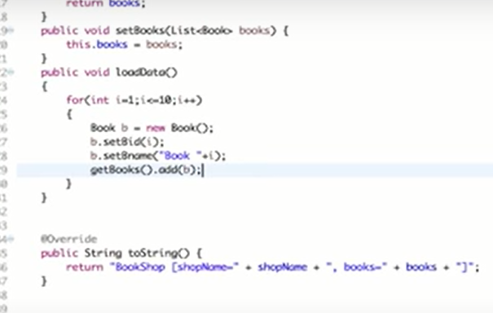

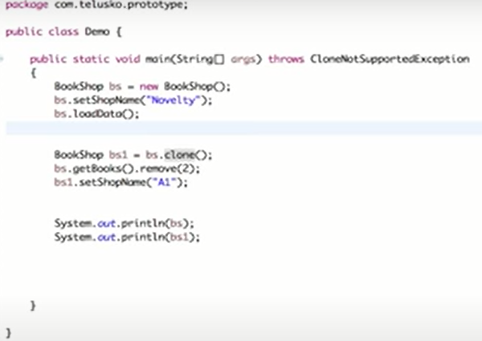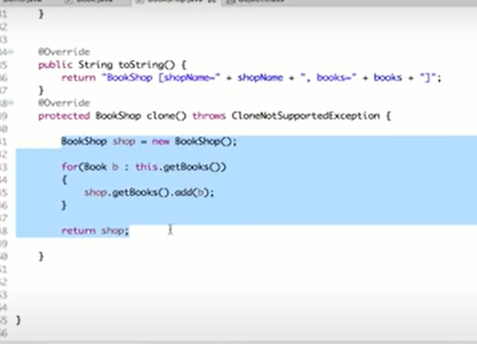

**Observer Design pattern (Behavioural):-**

Used mostly when you want to notify multiple objects about one object.

For ex : You want to notify all of the subscribers of a channel when you get to know that a youtube video is uploaded.

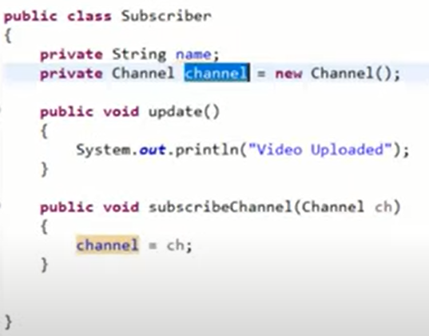 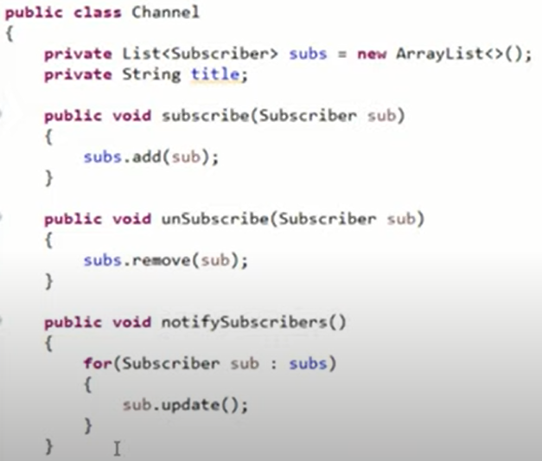

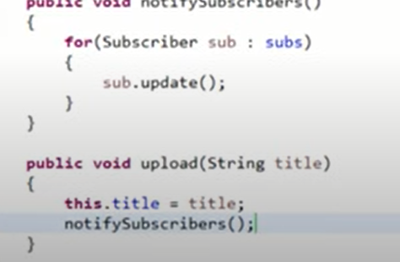

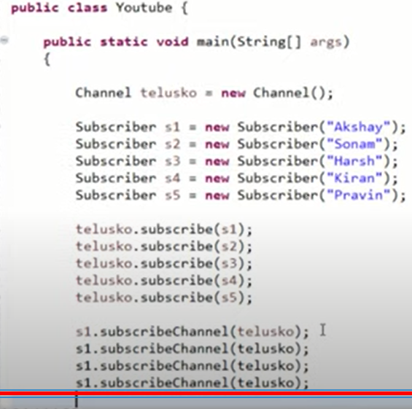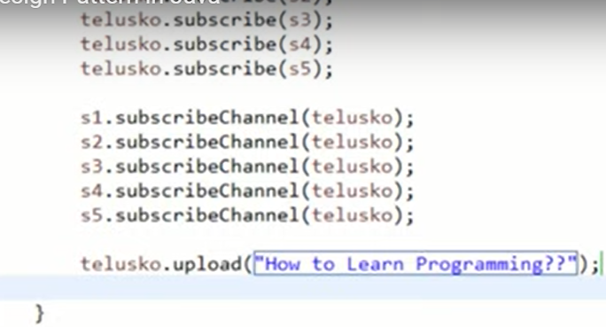

Example 2:- Coding Simplified

Whenever there is a change in system, update or notify to multiple observers. You have to register the observers as well before for particular Observee. In this case Observee is Delievery Data, Lets say if we have one more observe i.e. Price, and we want to notify user and seller about the price Up so we have to register User and seller observers to Price Observee.

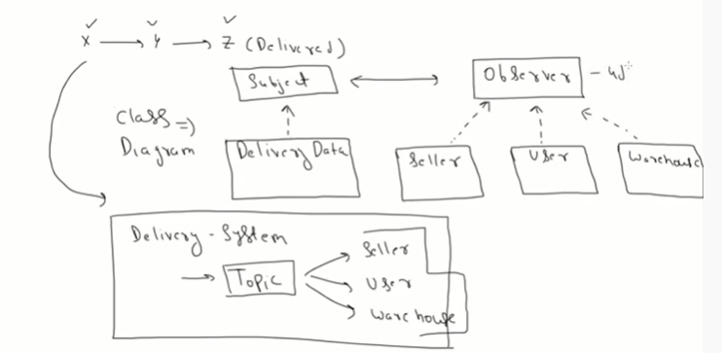

**package**observer;  
  
**import**java.util.ArrayList;  
**import**java.util.List;  
  
**interface**Subject {  
  **void**register(Observer obj);  
  **void**unregister(Observer obj);  
  **void**notifyObservers();  
}  
  
**class**DeliveryData **implements**Subject {  
  
  **private**List<Observer> observers;  
  **private**String location;  
    
  **public**DeliveryData() {  
    **this**.observers = **new**ArrayList<>();  
  }  
    
  @Override  
  **public void**register(Observer obj) {  
    observers.add(obj);  
  }  
  
  @Override  
  **public void**unregister(Observer obj) {  
      observers.remove(obj);  
  }  
  
  @Override  
  **public void**notifyObservers() {  
    **for**(Observer obj : observers) {  
      obj.update(location);  
    }  
  }  
  
  **public void**locationChanged() {  
    **this**.location = getLocation();  
    notifyObservers();  
  }  
    
  **public**String getLocation() {  
    **return**"YPlace";  
  }  
}  
  
  
**interface**Observer {  
  **public void**update(String location);  
}  
  
  
**class**Seller **implements**Observer {  
  **private**String location;  
    
  @Override  
  **public void**update(String location) {  
    **this**.location = location;  
    showLocation();  
  }  
  
  **public void**showLocation() {  
    System.out.println("Notification at Seller - Current Location: " + location);  
  }  
}  
  
**class**User **implements**Observer {  
  **private**String location;  
    
  @Override  
  **public void**update(String location) {  
    **this**.location = location;  
    showLocation();  
  }  
  
  **public void**showLocation() {  
    System.out.println("Notification at User - Current Location: " + location);  
  }  
}  
  
**class**DeliveryWarehouseCenter **implements**Observer {  
  **private**String location;  
    
  @Override  
  **public void**update(String location) {  
    **this**.location = location;  
    showLocation();  
  }  
  
  **public void**showLocation() {  
    System.out.println("Notification at Warehouse - Current Location: " + location);  
  }  
}  
  
**public class**ObserverPatternTest {  
  
  **public static void**main(String[] args) {  
    DeliveryData topic = **new**DeliveryData();  
      
    Observer obj1 = **new**Seller();  
    Observer obj2 = **new**User();  
    Observer obj3 = **new**DeliveryWarehouseCenter();  
      
    topic.register(obj1);  
    topic.register(obj2);  
    topic.register(obj3);  
      
    topic.locationChanged();  
      
    topic.unregister(obj3);  
      
    System.out.println();  
    topic.locationChanged();  
      
  }  
}

**Singleton Design pattern :- (Creational)**

**Used mostly when only one object is required for any class, usually used in logging caching extra where object does not changes.**

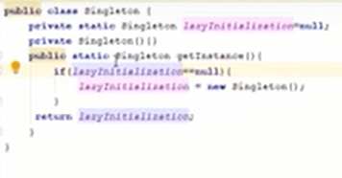

**Abstract Factory Design Pattern: (Creational)**

**It’s also called as Factory of factories. Where abstract factory calls separate factories which generates the objects of the classes.**

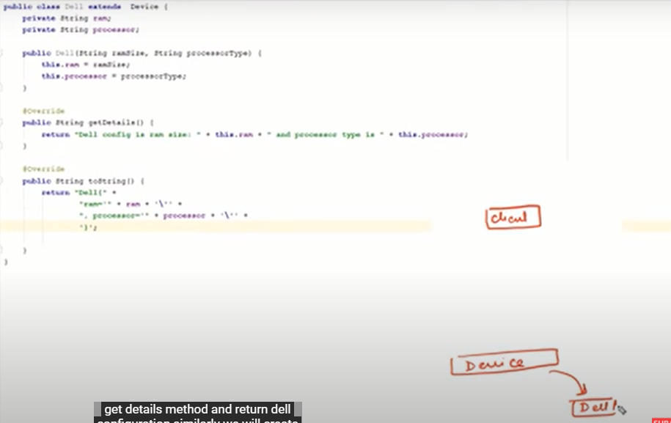

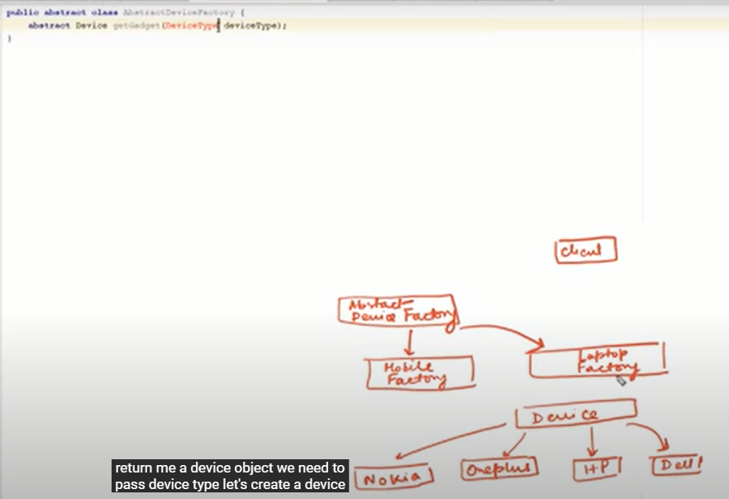

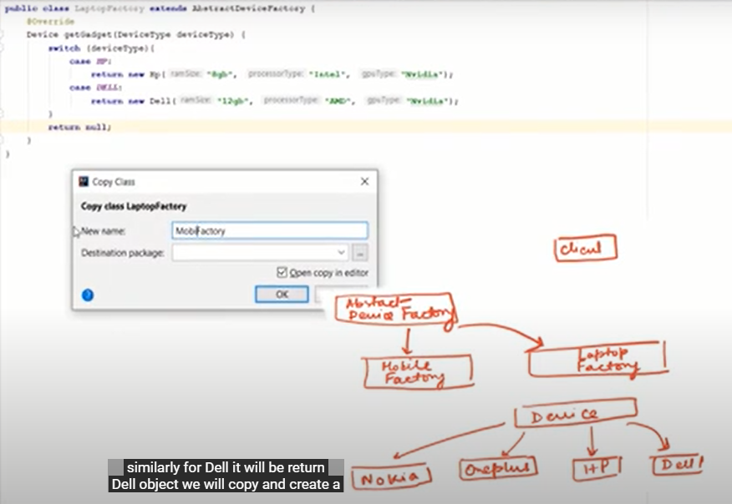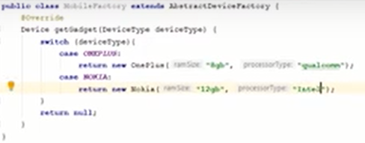

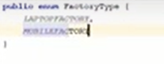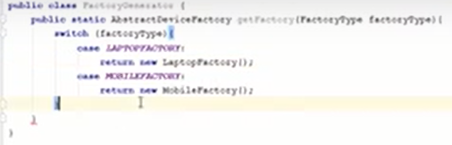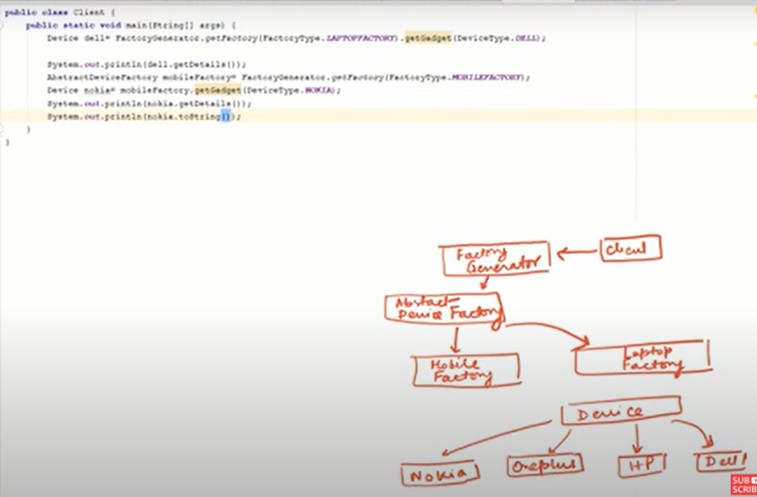

**Bridge Design Pattern (Structural)**

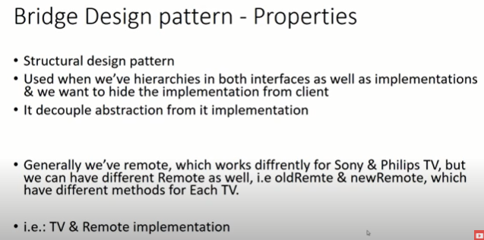

**package**bridge;  
  
**abstract class**TV {  
  Remote remote;  
    
  TV(Remote r) {  
    **this**.remote = r;  
  }  
    
  **abstract void**on();  
  **abstract void**off();  
}  
  
**class**Sony **extends**TV {  
  Remote remoteType;  
  Sony(Remote r) {  
    **super**(r);  
    **this**.remoteType = r;  
  }  
    
  **public void**on(){  
    System.out.print("Sony TV ON: ");  
    remoteType.on();  
  }  
      
  **public void**off(){  
    System.out.print("Sony TV OFF: ");  
    remoteType.off();  
  }  
}  
      
**class**Philips **extends**TV {  
  Remote remoteType;  
    
  Philips(Remote r) {  
    **super**(r);  
    **this**.remoteType = r;  
  }  
    
  **public void**on(){  
    System.out.print("Philips TV ON: ");  
    remoteType.on();  
  }  
      
  **public void**off(){  
    System.out.print("Philips TV OFF: ");  
    remoteType.off();  
  }  
}  
  
**interface**Remote {  
  **public void**on();  
  **public void**off();  
}  
  
**class**OldRemote **implements**Remote {  
  
  @Override  
  **public void**on() {  
    System.out.println("ON with Old Remote");  
  }  
  
  @Override  
  **public void**off() {  
    System.out.println("OFF with old Remote");  
  }  
    
}  
  
**class**NewRemote **implements**Remote {  
  
  @Override  
  **public void**on() {  
    System.out.println("ON with New Remote");  
  }  
  
  @Override  
  **public void**off() {  
    System.out.println("OFF with New Remote");  
  }  
    
}  
  
**public class**Client {  
  **public static void**main(String[] args) {  
    TV sonyOldRemote = **new**Sony(**new**OldRemote());  
    sonyOldRemote.on();  
    sonyOldRemote.off();  
    System.out.println();  
      
    TV sonyNewRemote = **new**Sony(**new**NewRemote());  
    sonyNewRemote.on();  
    sonyNewRemote.off();  
    System.out.println();  
      
    TV philipsOldRemote = **new**Philips(**new**OldRemote());  
    philipsOldRemote.on();  
    philipsOldRemote.off();  
    System.out.println();  
      
    TV philipsNewRemote = **new**Philips(**new**NewRemote());  
    philipsNewRemote.on();  
    philipsNewRemote.off();  
      
  }  
}

**Flyweight Design Pattern(Structural)**

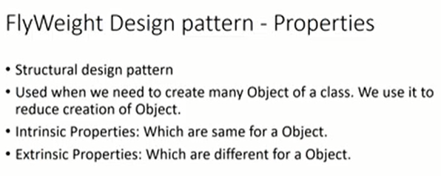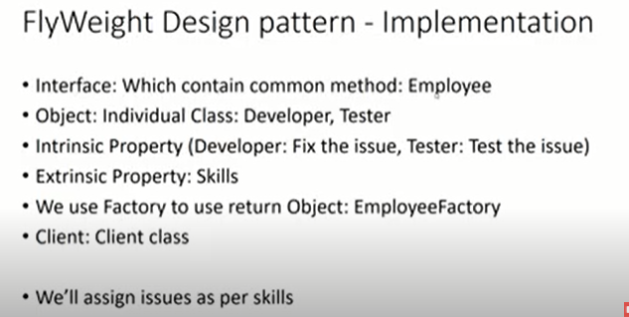

**Usually used when you want to create more than 10^5 objects for same type.**

**Like in counter strike game, you have a team of terrorists and anti terrorists, so for both the task is same, so we can create a single class and create multiple objects of it using a factory.**

**package**flyweight;  
  
**import**java.util.HashMap;  
**import**java.util.Random;  
  
**interface**Employee {  
  **public void**assignSkill(String skill);  
  **public void**task();  
}  
  
**class**Developer **implements**Employee {  
  
  **private final**String JOB;  
  **private**String skill;  
    
  **public**Developer() {  
    JOB = "Fix the issue";  
  }  
    
  @Override  
  **public void**assignSkill(String skill) {  
    **this**.skill = skill;  
  }  
  
  @Override  
  **public void**task() {  
    System.out.println("Developer with skill: " + **this**.skill + " with Job: " + JOB);  
  }  
    
}  
  
**class**Tester **implements**Employee {  
  
  **private final**String JOB;  
    
  **private**String skill;  
    
  **public**Tester() {  
    JOB = "Test the issue";  
  }  
    
  @Override  
  **public void**assignSkill(String skill) {  
    **this**.skill = skill;  
  }  
  
  @Override  
  **public void**task() {  
    System.out.println("Tester with Skill: " + **this**.skill + " with Job: " + JOB);  
  }  
    
}  
  
  
**class**EmployeeFactory {  
  **private static**HashMap<String, Employee> m = **new**HashMap<String, Employee>();  
    
  **public static**Employee getEmployee(String type) {  
    Employee p = **null**;  
    **if**(m.get(type) != **null**) {  
      p = m.get(type);  
    } **else**{  
      **switch**(type) {  
      **case**"Developer":   
        System.out.println("Developer Created");  
        p = **new**Developer();  
        **break**;  
      **case**"Tester":  
        System.out.println("Tester Created");  
        p = **new**Tester();  
        **break**;  
      **default**:  
        System.out.println("No Such Employee");  
      }  
        
      m.put(type, p);  
    }  
    **return**p;  
  }  
}  
  
**public class**Engineering {  
  
  **private static**String employeeType[] = {"Developer", "Tester"};  
  **private static**String skills[] = {"Java", "C++", ".Net", "Python"};  
    
  **public static void**main(String[] args) {  
    **for**(**int**i = 0; i < 10; i++) {  
      Employee e = EmployeeFactory.getEmployee(getRandEmployee());  
        
      e.assignSkill(getRandSkill());  
        
      e.task();  
    }  
  }  
    
  **public static**String getRandEmployee() {  
    Random r = **new**Random();  
    **int**randInt = r.nextInt(employeeType.length);  
      
    **return**employeeType[randInt];  
  }  
    
  **public static**String getRandSkill() {  
    Random r = **new**Random();  
    **int**randInt = r.nextInt(skills.length);  
      
    **return**skills[randInt];  
  }  
  
}

**Proxy Design Pattern(Structural Design pattern)**

**Proxy meaning filtering -> Usually used to control the access**

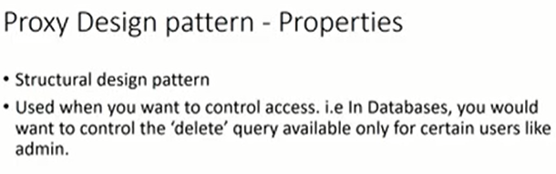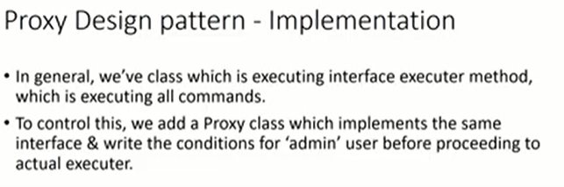

**package**proxy;  
**interface**DatabaseExecuter {  
  **public void**executeDatabase(String query) **throws**Exception;  
}  
  
**class**DatabaseExecuterImpl **implements**DatabaseExecuter {  
  
  @Override  
  **public void**executeDatabase(String query) **throws**Exception {  
    System.out.println("Going to execute Query: " + query);  
  }  
    
}  
  
**class**DatabaseExecuterProxy **implements**DatabaseExecuter {  
  **boolean**ifAdmin;  
  DatabaseExecuterImpl dbExecuter;  
    
  **public**DatabaseExecuterProxy(String name, String passwd) {  
    **if**(name == "Admin" && passwd == "Admin@123") {  
      ifAdmin = **true**;  
    }  
    dbExecuter = **new**DatabaseExecuterImpl();  
  }  
  
  @Override  
  **public void**executeDatabase(String query) **throws**Exception {  
    **if**(ifAdmin) {  
      dbExecuter.executeDatabase(query);  
    } **else**{  
      **if**(query.equals("DELETE")) {  
        **throw new**Exception("DELETE not allowed for non-admin user");  
      } **else**{  
        dbExecuter.executeDatabase(query);  
      }  
    }  
  }  
}  
  
**public class**ProxyPatternExample {  
  
  **public static void**main(String[] args) **throws**Exception {  
    DatabaseExecuter nonAdminExecuter = **new**DatabaseExecuterProxy("NonAdmin", "Admin@123");  
    nonAdminExecuter.executeDatabase("DELEE");  
      
    DatabaseExecuter nonAdminExecuterDELETE = **new**DatabaseExecuterProxy("NonAdmin", "Admin@123");  
    nonAdminExecuterDELETE.executeDatabase("DELETE");  
  
      
    DatabaseExecuter adminExecuter = **new**DatabaseExecuterProxy("Admin", "Admin@123");  
    adminExecuter.executeDatabase("DELETE");  
      
  }  
  
}

**Façade Design Patterns(Structural Design pattern)**

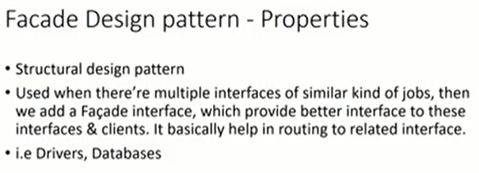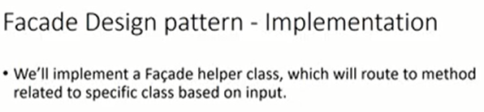

**package**facade;  
**import**java.sql.Driver;  
  
**class**Firefox {  
  **public static**Driver getFirefoxDriver() {  
    **return null**;  
  }  
    
  **public static void**generateHTMLReport(String test, Driver driver) {  
    System.out.println("Generating HTML Report for Firefox Driver");  
  }  
    
  **public static void**generateJUnitReport(String test, Driver driver) {  
    System.out.println("Generating JUNIT Report for Firefox Driver");  
  }  
}  
  
**class**Chrome {  
  **public static**Driver getChromeDriver() {  
    **return null**;  
  }  
    
  **public static void**generateHTMLReport(String test, Driver driver) {  
    System.out.println("Generating HTML Report for Chrome Driver");  
  }  
    
  **public static void**generateJUnitReport(String test, Driver driver) {  
    System.out.println("Generating JUNIT Report for Chrome Driver");  
  }  
}  
  
**class**WebExplorerHelperFacade {  
  **public static void**generateReports(String explorer, String report, String test) {  
    Driver driver = **null**;  
    **switch**(explorer) {  
    **case**"firefox":  
      driver = Firefox.getFirefoxDriver();  
      **switch**(report) {  
      **case**"html":  
        Firefox.generateHTMLReport(test, driver);  
        **break**;  
      **case**"junit":  
        Firefox.generateJUnitReport(test, driver);  
        **break**;  
      }  
    **break**;  
    **case**"chrome":  
      driver = Chrome.getChromeDriver();  
      **switch**(report) {  
      **case**"html":  
        Chrome.generateHTMLReport(test, driver);  
        **break**;  
      **case**"junit":  
        Chrome.generateJUnitReport(test, driver);  
        **break**;  
      }  
    }  
  }  
}  
  
  
**public class**FacadePatternExample {  
  
  **public static void**main(String[] args) {  
    String test = "CheckElementPresent";  
      
    WebExplorerHelperFacade.generateReports("firefox", "html", test);  
    WebExplorerHelperFacade.generateReports("firefox", "junit", test);  
    WebExplorerHelperFacade.generateReports("chrome", "html", test);  
    WebExplorerHelperFacade.generateReports("chrome", "junit", test);  
  }  
  
}

**Decorator Design Pattern**

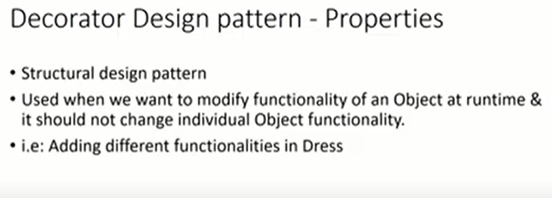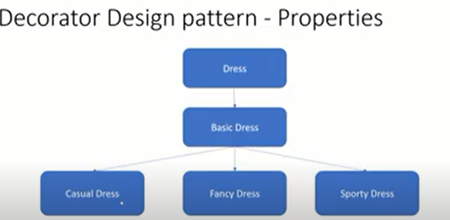

**package**decorator;  
  
**interface**Dress {  
  **public void**assemble();  
}  
  
**class**BasicDress **implements**Dress {  
  @Override  
  **public void**assemble() {  
    System.out.println("Basic Dress Features");  
  }  
}  
  
**class**DressDecorator **implements**Dress {  
  **protected**Dress dress;  
    
  **public**DressDecorator(Dress c) {  
    **this**.dress = c;  
  }  
  
  @Override  
  **public void**assemble() {  
    **this**.dress.assemble();  
  }  
}  
  
**class**CasualDress **extends**DressDecorator {  
  **public**CasualDress(Dress c) {  
    **super**(c);  
  }  
    
  @Override  
  **public void**assemble() {  
    **super**.assemble();  
    System.out.println("Adding Casual Dress Features");  
  }  
}  
  
  
**class**SportyDress **extends**DressDecorator {  
  **public**SportyDress(Dress c) {  
    **super**(c);  
  }  
    
  @Override  
  **public void**assemble() {  
    **super**.assemble();  
    System.out.println("Adding Sporty Dress Features");  
  }  
}  
  
**class**FancyDress **extends**DressDecorator {  
  **public**FancyDress(Dress c) {  
    **super**(c);  
  }  
    
  @Override  
  **public void**assemble() {  
    **super**.assemble();  
    System.out.println("Adding Fancy Dress Features");  
  }  
}  
  
**public class**DecoratorPatterTest {  
  
  **public static void**main(String[] args) {  
  
    Dress sportyDress = **new**SportyDress(**new**BasicDress());  
    sportyDress.assemble();  
    System.out.println();  
      
    Dress fancyDress = **new**FancyDress(**new**BasicDress());  
    fancyDress.assemble();  
    System.out.println();  
      
    Dress casualDress = **new**CasualDress(**new**BasicDress());  
    casualDress.assemble();  
    System.out.println();  
      
      
    Dress sportyFancyDress = **new**SportyDress(**new**FancyDress(**new**BasicDress()));  
    sportyFancyDress.assemble();  
    System.out.println();  
      
    Dress casualFancyDress = **new**CasualDress(**new**FancyDress(**new**BasicDress()));  
    casualFancyDress.assemble();  
      
  }  
}

**Object Pool Design Pattern(Creational) :-** [**https://www.javatpoint.com/object-pool-pattern**](https://www.javatpoint.com/object-pool-pattern)

**Chain of Responsibility Pattern (Behavioural) :-**

In chain of responsibility, sender sends a request to a chain of objects. The request can be handled by any object in the chain.

A Chain of Responsibility Pattern says that just **"avoid coupling the sender of a request to its receiver by giving multiple objects a chance to handle the request".** For example, an ATM uses the Chain of Responsibility design pattern in money giving process.

In other words, we can say that normally each receiver contains reference of another receiver. If one object cannot handle the request then it passes the same to the next receiver and so on.

Advantage of Chain of Responsibility Pattern

* It reduces the coupling.
* It adds flexibility while assigning the responsibilities to objects.
* It allows a set of classes to act as one; events produced in one class can be sent to other handler classes with the help of composition.

Usage of Chain of Responsibility Pattern:

It is used:

* When more than one object can handle a request and the handler is unknown.
* When the group of objects that can handle the request must be specified in dynamic way.

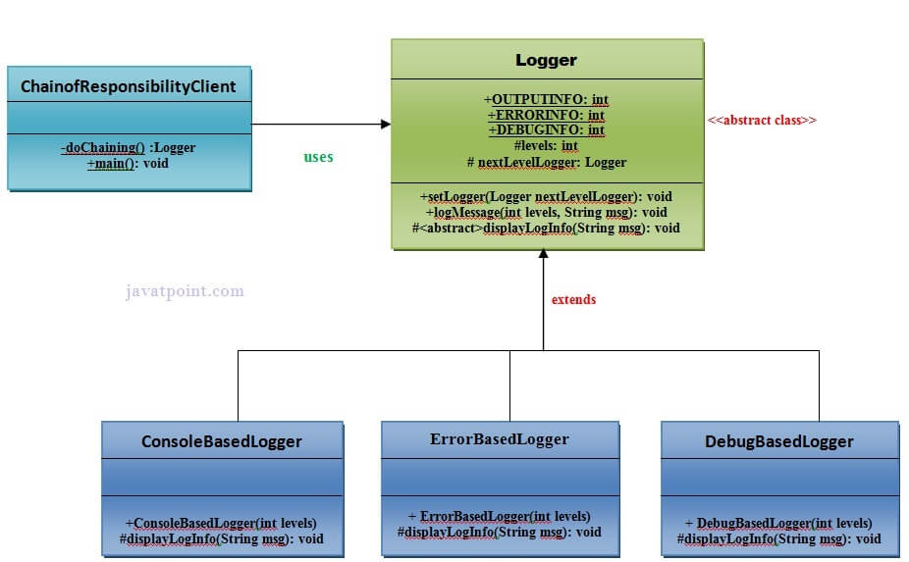

Implementation of above UML:

Step 1

Create a **Logger** abstract class.

1. **public** **abstract** **class** Logger {
2. **public** **static** **int** OUTPUTINFO=1;
3. **public** **static** **int** ERRORINFO=2;
4. **public** **static** **int** DEBUGINFO=3;
5. **protected** **int** levels;
6. **protected** Logger nextLevelLogger;
7. **public** **void** setNextLevelLogger(Logger nextLevelLogger) {
8. **this**.nextLevelLogger = nextLevelLogger;
9. }
10. **public** **void** logMessage(**int** levels, String msg){
11. **if**(**this**.levels<=levels){
12. displayLogInfo(msg);
13. }
14. **if** (nextLevelLogger!=**null**) {
15. nextLevelLogger.logMessage(levels, msg);
16. }
17. }
18. **protected** **abstract** **void** displayLogInfo(String msg);
19. }

Step 2

Create a **ConsoleBasedLogger** class.

*File: ConsoleBasedLogger.java*

1. **public** **class** ConsoleBasedLogger **extends** Logger {
2. **public** ConsoleBasedLogger(**int** levels) {
3. **this**.levels=levels;
4. }
5. @Override
6. **protected** **void** displayLogInfo(String msg) {
7. System.out.println("CONSOLE LOGGER INFO: "+msg);
8. }
9. }

Step 3

Create a **DebugBasedLogger** class.

*File: DebugBasedLogger.java*

1. **public** **class** DebugBasedLogger **extends** Logger {
2. **public** DebugBasedLogger(**int** levels) {
3. **this**.levels=levels;
4. }
5. @Override
6. **protected** **void** displayLogInfo(String msg) {
7. System.out.println("DEBUG LOGGER INFO: "+msg);
8. }
9. }// End of the DebugBasedLogger class.

Step 4

Create a **ErrorBasedLogger** class.

*File: ErrorBasedLogger.java*

1. **public** **class** ErrorBasedLogger **extends** Logger {
2. **public** ErrorBasedLogger(**int** levels) {
3. **this**.levels=levels;
4. }
5. @Override
6. **protected** **void** displayLogInfo(String msg) {
7. System.out.println("ERROR LOGGER INFO: "+msg);
8. }
9. }// End of the ErrorBasedLogger class.

Step 5

Create a **ChainOfResponsibilityClient** class.

*File: ChainofResponsibilityClient.java*

1. **public** **class** ChainofResponsibilityClient {
2. **private** **static** Logger doChaining(){
3. Logger consoleLogger = **new** ConsoleBasedLogger(Logger.OUTPUTINFO);
5. Logger errorLogger = **new** ErrorBasedLogger(Logger.ERRORINFO);
6. consoleLogger.setNextLevelLogger(errorLogger);
8. Logger debugLogger = **new** DebugBasedLogger(Logger.DEBUGINFO);
9. errorLogger.setNextLevelLogger(debugLogger);
11. **return** consoleLogger;
12. }
13. **public** **static** **void** main(String args[]){
14. Logger chainLogger= doChaining();
16. chainLogger.logMessage(Logger.OUTPUTINFO, "Enter the sequence of values ");
17. chainLogger.logMessage(Logger.ERRORINFO, "An error is occured now");
18. chainLogger.logMessage(Logger.DEBUGINFO, "This was the error now debugging is compeled");
19. }
20. }

# **Template Pattern**

A Template Pattern says that "just define the skeleton of a function in an operation, deferring some steps to its subclasses".

## **Benefits:**

* It is very common technique for reusing the code.This is only the main benefit of it.

## **Usage:**

* It is used when the common behavior among sub-classes should be moved to a single common class by avoiding the duplication.

## **UML for Template Pattern:**

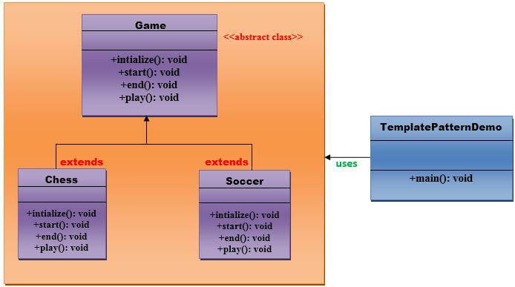

## **Implementation of Template Pattern:**

**Step 1:**

Create a Game *abstract* class.

1. //This is an abstract class.
2. **public** **abstract** **class** Game {
4. **abstract** **void** initialize();
5. **abstract** **void** start();
6. **abstract** **void** end();
8. **public** **final** **void** play(){
10. //initialize the game
11. initialize();
13. //start game
14. start();
16. //end game
17. end();
18. }
19. }// End of the Game abstract class.

**Step 2:**

Skip Ad

Create a *Chess* class that will extend Game abstract class for giving the definition to its method.

1. //This is a class.
3. **public** **class** Chess **extends** Game {
4. @Override
5. **void** initialize() {
6. System.out.println("Chess Game Initialized! Start playing.");
7. }
8. @Override
9. **void** start() {
10. System.out.println("Game Started. Welcome to in the chess game!");
11. }
12. @Override
13. **void** end() {
14. System.out.println("Game Finished!");
15. }
16. }// End of the Chess class.

**Step 3:**

Create a *Soccer* class that will extend Game abstract class for giving the definition to its method.

1. //This is a class.

4. **public** **class** Soccer **extends** Game {
6. @Override
7. **void** initialize() {
8. System.out.println("Soccer Game Initialized! Start playing.");
9. }
11. @Override
12. **void** start() {
13. System.out.println("Game Started. Welcome to in the Soccer game!");
14. }
16. @Override
17. **void** end() {
18. System.out.println("Game Finished!");
19. }
20. }// End of the Soccer class.

**Step 4:**

Create a *TemplatePatternDemo* class.

1. //This is a class.
2. **public** **class** TemplatePatternDemo {
4. **public** **static** **void** main(String[] args) **throws** InstantiationException, IllegalAccessException, ClassNotFoundException {
6. Class c=Class.forName(args[0]);
7. Game game=(Game) c.newInstance();
8. game.play();
9. }
10. }// End of the Soccer class.

# **Command Pattern**

1. [Command Design Pattern](https://www.javatpoint.com/command-pattern)
2. [Advantage of Command DP](https://www.javatpoint.com/command-pattern#adv)
3. [Usage of Command DP](https://www.javatpoint.com/command-pattern#usage)
4. [UML of Command DP](https://www.javatpoint.com/command-pattern#uml)
5. [Example of Command DP](https://www.javatpoint.com/command-pattern#ex)

A Command Pattern says that "*encapsulate a request under an object as a command and pass it to invoker object. Invoker object looks for the appropriate object which can handle this command and pass the command to the corresponding object and that object executes the command*".

It is also known as **Action or Transaction.**

#### Advantage of command pattern

* It separates the object that invokes the operation from the object that actually performs the operation.
* It makes easy to add new commands, because existing classes remain unchanged.

#### Usage of command pattern:

It is used:

* When you need parameterize objects according to an action perform.
* When you need to create and execute requests at different times.
* When you need to support rollback, logging or transaction functionality.

### **Example of command pattern**

Let's understand the example of adapter design pattern by the above UML diagram.

7M

111

Triggers in SQL (Hindi)

#### UML for command pattern:

##### **These are the following participants of the Command Design pattern:**

* **Command** This is an interface for executing an operation.
* **ConcreteCommand** This class extends the Command interface and implements the execute method. This class creates a binding between the action and the receiver.
* **Client** This class creates the ConcreteCommand class and associates it with the receiver.
* **Invoker** This class asks the command to carry out the request.
* **Receiver** This class knows to perform the operation.

#### Implementation of above UML:

#### Step 1

Create a **ActionListernerCommand** interface that will act as a Command.

1. **public** **interface** ActionListenerCommand {
2. **public** **void** execute();
3. }

#### Step 2

Create a **Document** class that will act as a Receiver.

*File: Document.java*

1. **public** **class** Document {
2. **public** **void** open(){
3. System.out.println("Document Opened");
4. }
5. **public** **void** save(){
6. System.out.println("Document Saved");
7. }
8. }

#### Step 3

Create a **ActionOpen** class that will act as an ConcreteCommand.

*File: ActionOpen.java*

1. **public** **class** ActionOpen **implements** ActionListenerCommand{
2. **private** Document doc;
3. **public** ActionOpen(Document doc) {
4. **this**.doc = doc;
5. }
6. @Override
7. **public** **void** execute() {
8. doc.open();
9. }
10. }

#### Step 4

Create a **ActionSave** class that will act as an ConcreteCommand.

*File: AdapterPatternDemo.java*

1. **public** **class** ActionSave **implements** ActionListenerCommand{
2. **private** Document doc;
3. **public** ActionSave(Document doc) {
4. **this**.doc = doc;
5. }
6. @Override
7. **public** **void** execute() {
8. doc.save();
9. }
10. }

#### Step 5

Create a **MenuOptions** class that will act as an Invoker.

*File: ActionSave.java*

1. **public** **class** ActionSave **implements** ActionListenerCommand{
2. **private** Document doc;
3. **public** ActionSave(Document doc) {
4. **this**.doc = doc;
5. }
6. @Override
7. **public** **void** execute() {
8. doc.save();
9. }
10. }

#### Step 6

Create a **CommanPatternClient** class that will act as a Client.

*File: AdapterPatternDemo.java*

1. **public** **class** CommandPatternClient {
2. **public** **static** **void** main(String[] args) {
3. Document doc = **new** Document();
5. ActionListenerCommand clickOpen = **new** ActionOpen(doc);
6. ActionListenerCommand clickSave = **new** ActionSave(doc);
8. MenuOptions menu = **new** MenuOptions(clickOpen, clickSave);
10. menu.clickOpen();
11. menu.clickSave();
12. }
13. }

**Command Pattern Example 2 :-**

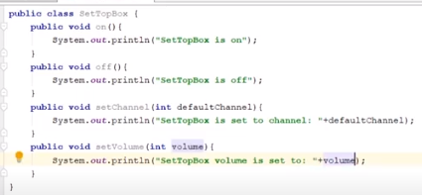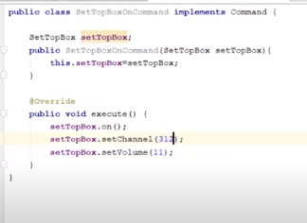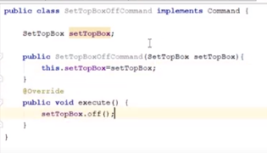

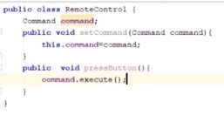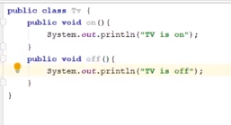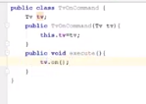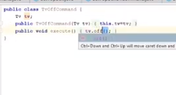

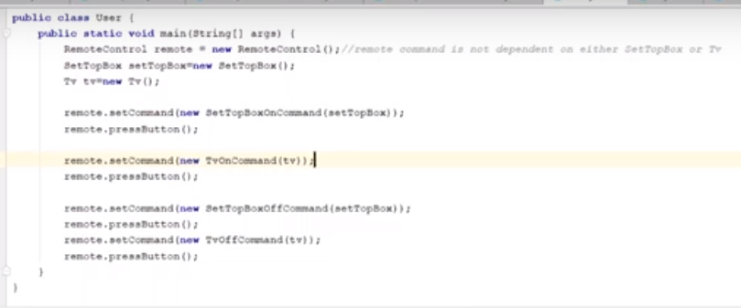

**Strategy Pattern**

# **Strategy Pattern**

A Strategy Pattern says that "defines a family of functionality, encapsulate each one, and make them interchangeable".

The Strategy Pattern is also known as Policy.

## **Benefits:**

* It provides a substitute to subclassing.
* It defines each behavior within its own class, eliminating the need for conditional statements.
* It makes it easier to extend and incorporate new behavior without changing the application.

## **Usage:**

* When the multiple classes differ only in their behaviors.e.g. Servlet API.
* It is used when you need different variations of an algorithm.

### **Strategy Pattern in (Core Java API's) or JSE 7 API's:**

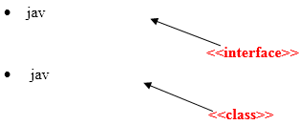

### **Strategy Pattern in (Advance Java API's) or JEE 7 API's:**

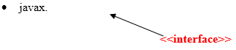

## **UML for Strategy Pattern:**

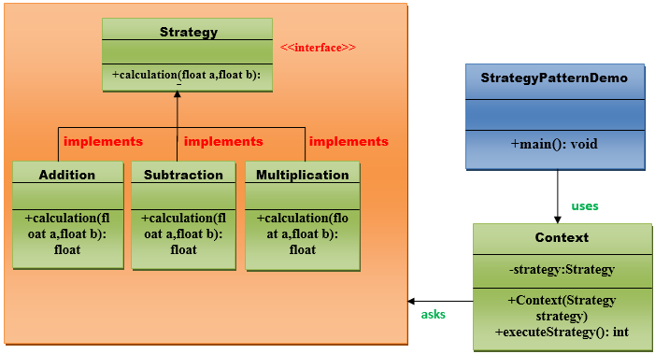

## **Implementation of Strategy Pattern:**

**Step 1:**

Create a *Strategy* interface.

1. //This is an interface.
3. **public** **interface** Strategy {
5. **public** **float** calculation(**float** a, **float** b);
7. }// End of the Strategy interface.

**Step 2:**

Create a *Addition* class that will implement Startegy interface.

1. //This is a class.
2. **public** **class** Addition **implements** Strategy{
4. @Override
5. **public** **float** calculation(**float** a, **float** b) {
6. **return** a+b;
7. }
9. }// End of the Addition class.

**Step 3:**

Create a *Subtraction* class that will implement Startegy interface.

1. //This is a class.
2. **public** **class** Subtraction  **implements** Strategy{
4. @Override
5. **public** **float** calculation(**float** a, **float** b) {
6. **return** a-b;
7. }
9. }// End of the Subtraction class.

**Step 4:**

Create a Multiplication class that will implement Startegy interface.

1. //This is a class.
3. **public** **class** Multiplication **implements** Strategy{
5. @Override
6. **public** **float** calculation(**float** a, **float** b){
7. **return** a*b;
8. }
9. }// End of the Multiplication class.

**Step 5:**

Create a *Context* class that will ask from Startegy interface to execute the type of strategy.

1. //This is a class.

4. **public** **class** Context {
6. **private** Strategy strategy;
8. **public** Context(Strategy strategy){
9. **this**.strategy = strategy;
10. }
12. **public** **float** executeStrategy(**float** num1, **float** num2){
13. **return** strategy.calculation(num1, num2);
14. }
15. }// End of the Context class.

**Step 6:**

Create a *StartegyPatternDemo* class.

1. //This is a class.
2. **import** java.io.BufferedReader;
3. **import** java.io.IOException;
4. **import** java.io.InputStreamReader;
6. **public** **class** StrategyPatternDemo {
8. **public** **static** **void** main(String[] args) **throws** NumberFormatException, IOException {
10. BufferedReader br=**new** BufferedReader(**new** InputStreamReader(System.in));
11. System.out.print("Enter the first value: ");
12. **float** value1=Float.parseFloat(br.readLine());
13. System.out.print("Enter the second value: ");
14. **float** value2=Float.parseFloat(br.readLine());
15. Context context = **new** Context(**new** Addition());
16. System.out.println("Addition = " + context.executeStrategy(value1, value2));
18. context = **new** Context(**new** Subtraction());
19. System.out.println("Subtraction = " + context.executeStrategy(value1, value2));
21. context = **new** Context(**new** Multiplication());
22. System.out.println("Multiplication = " + context.executeStrategy(value1, value2));
23. }
25. }// End of the StrategyPatternDemo class.

**State Design Pattern**

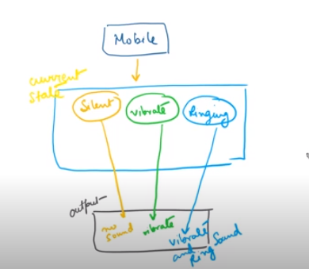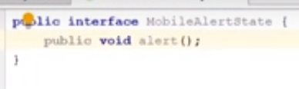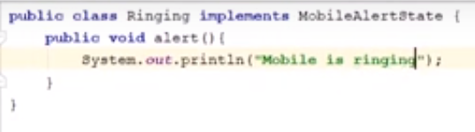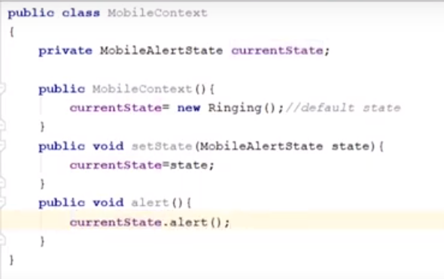

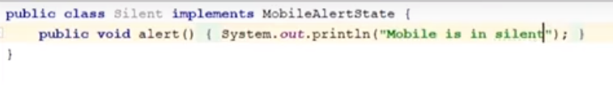

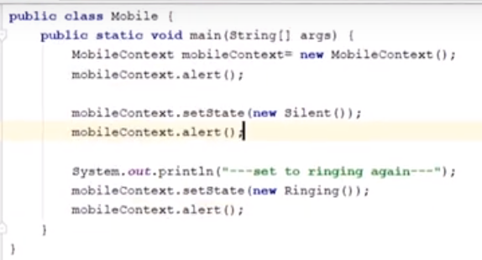

**Example 2:-** [**https://www.javatpoint.com/state-pattern**](https://www.javatpoint.com/state-pattern)